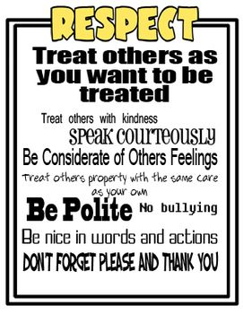

**Ten Ways To Practice Respect**

***Respect means to honor and to show consideration and value to people, property, the environment, and yourself. It means to treat others well even if they look, act, or believe differently than you do.***

* Respond to the following questions in your writing journal, "How does it feel to be respected?" "What do people say or do that makes you feel respected"?
* Explore what it feels like to walk in someone else's shoes. Discuss how sometimes people misunderstand what it feels like to do something if they haven't tried it for themselves. Think about a time you may have been misunderstood. Write a paragraph to explain how it feels to walk in someone else's shoes.
* Think about how would you like to be treated. Discuss the importance of treating others with respect. Use examples such as being polite, letting people be different, and giving others personal space.
* Developing a "People I Respect" list and why. As you develop this, consider the key components of the Golden Rule, tolerance and acceptance, nonviolence, and courtesy.
* Create a story for younger children about respect. Share stories with younger students.
* Discuss how important it is to respect ourselves. Brainstorm a list of words and phrases we might say to ourselves. Change the words and phrases that are negative into positive ones. For example, "I'll never get this math". Change this to "With practice and help, I will eventually get this math".
* Create cartoon strips showing respectful actions.
* Write an "Appreciation Letter" to your grandparent(s) or someone special to you. Tell that person how you feel about them and note some of their special qualities.
* Every day this week give a sincere compliment to someone. Create a weekly planner that will help you track your behavior. Each day you must write who you gave the compliment to and describe their reaction.
* Think of someone who is respectful and talk about why they would be a good friend.